

**Title:MINDSYNC-MENTALHEALTH ASSISTENCE**

**Team Details:**

**Names:ABITHASHREE.S / 211423104009,ASITHA.L/211423104068**

**Batch Number:22 Domain:ARTIFICIAL INTELLLIGENCE**

**COORDINATOR NAME: Dr.KAVITHASUBRAMANI**

**GUIDE NAME: Dr.MAHESWARI**

**Date:29-10-2025**

1. Introduction

AGENDA

Problem Statement, Project Scope, SDG Alignment (Health & Innovation).

1. System Architecture & Design

Block Diagram, DFD, Use-Case, and Class Diagrams (The System Blueprint).

1. Core Components & Logic

Module Specifications (Multimodal AI, CBT/Mindfulness, Crisis Detection) and Requirements.

1. Justification & Results

Positive Impact (24/7, Stigma-Free), and Experimental Demos (Text, Voice, Face, Multilingual performance).

1. Conclusion & FutureProject Showcase/Achievements, Integration with Digital Healthcare, and Final Conclusion.

# SDGs and TARGETs



#### Primary Goal No: 3 – Good Health and Well-being

* + - Target1:Promote mental health awareness through accessible AI tools
    - Target 2: Strengthen psychological support systems in underserved areas
    - Target 3: Integrate AI mental health tools into healthcare policy (SDG 3.4)

#### Secondary Goal No: 9 – Industry, Innovation and Infrastructure

* + Target 1: Encourage AI-driven innovation in digital healthcare
  + Target 2: Enhance infrastructure for AI-based remote health monitoring
  + Target 3: Improve access to mental wellness tech platforms globally.

#### Tertiary Goal No: 10 – Reduced Inequalities

* + Target 1: Ensure equal access to mental health support regardless of region
  + Target 2: Develop multilingual and culturally sensitive AI models
  + Target 3: Promote digital inclusivity in mental wellness

## BASEPAPER DETAILS

* + - Title: Conversational AI for Mental Health Support
    - Authors: Swarali Kulkarni, Erum Parkar, Rutuja Lonkar, Dr. Preksha Pareek, Dr. Shruti Patil, Sheetal Kusal – Symbiosis Institute of Technology, Pune, India
    - Journal/Conference: IEEE 2024 MIT Art, Design and Technology School of Computing International Conference (MITADTSoCiCon)
    - Location: Pune, India Dates: April 25–27, 2024
    - Year: 2024
    - Publisher: IEEE (Institute of Electrical and Electronics Engineers) DOI: 10.1109/MITADTSoCiCon60330.2024.10575117.

# Problem Statement



Develop **MindSync**, an AI-powered mental health assistant that leverages natural language processing (NLP), speech recognition, and facial emotion detection to analyze user emotions and provide personalized emotional support, mood tracking, and therapy scheduling — all without the need for IoT or wearable devices.

-Students and youth

* -Urban populations
* -Rural populations
* -General population facing stigma
* -One-line Summary: “Millions suffer silently due to stigma, cost, or
* unavailability of support.”
* -Solution: “Talk Freely. Heal Quietly. Powered by AI.”
* -AI chatbot offering anonymous, empathetic, and 24x7 support.

**Abstract**

* + -AI-powered Support: Utilizes AI, especially Natural Language Processing (NLP) and
  + Machine Learning (ML), to deliver accessible and personalized mental health support.
  + -Mimics Human Conversation: Designed to engage users in human-like conversations,
  + offering a confidential and non-judgmental space.
  + -Addresses Global Crisis: Aims to overcome barriers like stigma, cost, and limited
  + access to traditional mental health services.
  + -Complementary Tool: Functions as a valuable addition to professional therapy, not a
  + replacement.
  + -24/7 Availability: Provides immediate, round-the-clock support.
  + -Integrates Therapy Techniques: Often incorporates evidence-based methods such as
  + Cognitive Behavioral Therapy (CBT) and mindfulness to help users manage various
  + mental health concerns.

# Research and Literature Review

1. Mental Health Support Using Gen-AI Shot Prompting Technique and Vector Embeddings

|  |  |
| --- | --- |
| **Aspect** | **Details** |
| **Author** | Dr. Ponmagal R.S. et al. |
| **Summary** | This conference paper proposes a novel approach to mental health support using a combination of "Gen‑ AI Shot" prompting techniques and vector embeddings. The method involves using dimension‑ reduction methods—possibly including principal component analysis (PCA)—alongside vector embedding models (such as GloVe) to encode features of facial expression data. |
| **Relevance** | **nnovative Multimodal Strategy:** Combines generative AI prompting with visual embeddings, enriching mental health assessment beyond text- based methods.  **Practical Clinical Applications:** Targets machine-assisted estimation of mental health indicators—such as depression or schizophrenia—from facial expression patterns. |
| **Gaps** | **Limited Modality Scope:** Focus is on facial expressions only; mental health symptoms are multimodal—textual, auditory, behavioral aspects are not considered. |
| **Impact** | **Early Detection Tools:** Embedding-driven generative AI could assist in non-invasive, real-time mental health monitoring (e.g., via webcams or mobile devices).  **Augmenting Clinician Capabilities:** Automated assessments could be integrated into telehealth platforms, supporting clinicians with supplementary data. |

# Research and Literature Review

1. MindMate: AI‑ Powered Multilingual Mental Health Chatbot with Personalized Voice and Text Support with Rasa and

S

|  |  |
| --- | --- |
| t**A**r**sp**e**e**a**ct**mlit | **Details** |
| **Author** | Dharshini S*, Samson Arun Raj A, Venkatesan R |
| **Summary** | MindMate is an AI-driven chatbot designed to provide empathetic mental health support via both **voice and text**, built using **Rasa** for natural language understanding and dialogue management, and **Streamlit** for creating an intuitive user interface. |
| **Relevance** | **Accessibility & Empathy:** Offers non-judgmental mental health support accessible anytime, from anywhere, reducing barriers like stigma or resource scarcity.  **Inclusivity through Language:** Multilingual capability expands reach across diverse linguistic groups, promoting usability and comfort |
| **Gaps** | **Evaluation Metrics:** The paper doesn’t discuss quantitative measures of performance, user satisfaction, or comparative baselines.  **Ethical & Data Concerns:** Lacks detail on privacy safeguards, handling of sensitive data, or bias mitigation. |
| **Impact** | **Broader Mental Health Access:** MindMate democratizes mental health support using voice and text, reducing access barriers, especially for underserved populations.  **User Comfort & Engagement:** Multilingual and voice-enabled features make users feel heard and understood, fostering engagement and emotional validation. |

# Research and Literature Review

1. Conversational AI for Mental Health Support

|  |  |
| --- | --- |
| **Aspect** | **Details** |
| **Author** | Swarali Kulkarni, Erum Parkar, Rutuja Lonkar, Preksha Pareek, Shruti Patil, Sheetal Kusal |
| **Summary** | The system implements **intent-based dialogue flows**, supporting symptom detection and responses aligned with user needs. It leverages both text and audio inputs to understand user sentiment and provide supportive conversational replies. |
| **Relevance** | Demonstrates a real-world-implemented **mental health-focused chatbot** developed with ML/NLP techniques. |
| **Gaps** | **Unclear real-time capability and offline support**—likely relies on internet/cloud inference. |
| **Impact** | Adds to the growing corpus of Indian-led conversational AI efforts for mental health. Reinforces feasibility of chatbots using simple inputs (text + audio) in support contexts. |

# Research and Literature Review

1. *Mind Fusion: Utilizing the Mixstyle Neural Networks in Constructing Mental Health Diagnosis and Therapy for Individual Patient*

|  |  |
| --- | --- |
| **Aspect** | **Details** |
| **Author** | N. N. Jose; Dr. Rashmi Deshpande. |
| **Summary** | The paper proposes **Mind Fusion**, an individualized mental health system leveraging **MixStyle neural network** techniques to enhance diagnosis and therapeutic tailoring. By employing MixStyle—originally introduced for domain generalization through feature statistic mixing—the framework seeks to adapt models to individual patients, thereby improving personalization and robustness across varied populations. |
| **Relevance** | **Personalized Mental Health Support:** Targets individual-specific diagnostics and therapeutic suggestions, aligning with the growing emphasis on **precision psychiatry** and patient-centric care. |
| **Gaps** | Lack of Empirical Detail,Clinical and Ethical Context Omitted. |
| **Impact** | * **Scalable Precision Support:** If operationalized effectively, Mind Fusion could support clinicians by providing adaptive, personalized diagnostic/therapeutic assistance across diverse patient profiles. |

# Research and Literature Review

1. ELEVATE: An AI‑ Driven Virtual Companion for Nurturing

Mental Health Support for Students

|  |  |
| --- | --- |
| **Aspect** | **Details** |
| **Authors** | Angeline R; Mohammed Aman Sajith; Roshini S; Shasti M |
| **Summary** | ELEVATE is an AI-powered virtual companion designed to nurture and support student mental health. It functions as a personalized chatbot—delivered via voice and/or text—designed specifically for students, leveraging modern AI techniques to provide empathetic, peer-like interactions and accessibility anytime, anywhere. |
| **Relevance** | Aligns with growing trends of deploying **AI companions and digital tools** to assist with student well-being and emotional resilience. AI chatbots and virtual assistants are increasingly incorporated in educational environments to supplement human resources and provide scalable support |
| **Gaps** | Ethical Considerations,Lack of Empirical Evidence |
| **Impact** | **Promoting Early Emotional Engagement:** The virtual companion may encourage students to recognize and share emotional concerns early, acting as a first line of support before issues escalate. |

LITERATURE REVIEW

|  |  |  |  |  |
| --- | --- | --- | --- | --- |
| **6** | Maybhate, S., Deogade, S., Sinap, S., et al. | 2024 | Supports the foundational concept of a **Mental Health Chatbot**. | Presents 'Bliss Bot', a basic concept and implementation of a mental health support  chatbot. |
| **7** | Bhaduri R, J., Vijayaraghavan, A., Karthik R, A., et al. | 2024 | Reinforces the utility of **AI-Powered Chatbots** in treatment scenarios. | Explores the use of AI chatbot technology specifically for administering mental health treatment protocols. |
| **8** | Parthiban, B. P., Subash, R., L. G., et al. | 2024 | Justifies the **AI-Based Mental Health Assisted Chatbot System**  as a viable solution. | Presents an implemented system using AI to provide assistance and support as a  chatbot. |
| **9** | Siddique, S., & Alsayoud, F. | 2025 | Introduces **RAG (Retrieval-Augmented Generation) Chatbots**  for enhanced support quality. | Focuses on using multi-tiered RAG architecture to improve the depth and relevance of mental health support  responses. |
| **10** | Bhave, U., Mhatre, M. N., Joshi, J. A. S., et al. | 2024 | Supports the concept of a dedicated **Mental Health Companion**. | Describes 'Mind Well Solace', a companion system designed to assist with mental well-  being. |
| **11,12** | Cook, B. L., Progovac, A. M., Chen, P., et al. | 2016 | Foundational justification for using **NLP to predict suicidal ideation** and critical symptoms. | Demonstrates the effectiveness of Natural Language Processing in identifying and predicting severe psychiatric symptoms from text data. |
| **13** | Akbar, D. A., Bewasana, D. A. D., Mahfud, A. Z., et al. | 2023 | Focuses on **Early Detection of Mental Health** issues using new breakthroughs. | Proposes 'InnerCheck', a system aimed at the early identification of mental health  concerns. |
| **14** | Sri, B. U., Dasoju, V., Avinash, G. J., et al. | 2024 | Supports the focus on **Anonymity** and overcoming barriers in mental health assistance. | Discusses 'SolaceNet', a platform  emphasizing anonymity to encourage people to seek therapy. |
| **15** | Natania, S., Juliet, S., & Ebenezer, S. | 2025 | Explores **Real-Time Prediction** using specific ML algorithms like **SVM** (Support Vector Machine). | Describes an AI chatbot that uses SVM for real-time mental health prediction and  diagnosis. |
| **16** | Amirhosseini, M. H., Ayodele, A. L., & Karami, A. | 2024 | Strongly supports the use of **Multimodal Data** (Multimodal Analysis Module) for better prediction. | Investigates using Machine Learning on diverse, multimodal data to predict depression severity and personalized risk  factors. |
| **17** | Tang, H., Rekavandi, A. M., Rooprai, D., et al. | 2024 | Focuses on **Explainable AI (XAI)** in critical areas like **Suicide Risk Assessment**. | Analyzes the need for transparent and explainable AI models, particularly when assessing high-stakes risks like suicide. |

### Product Architecture and Design/ Block Diagram

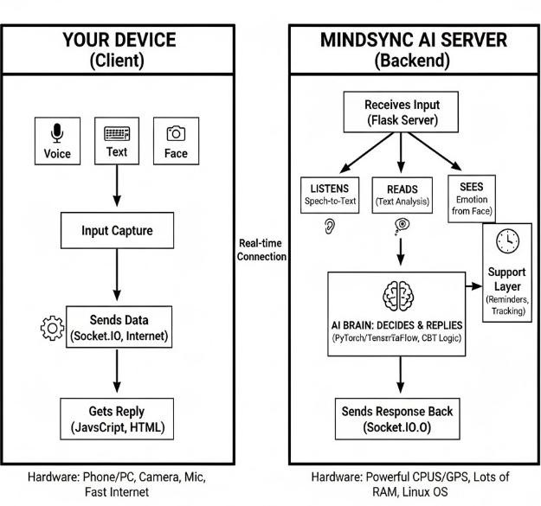

USE-CASE DIAGRAM

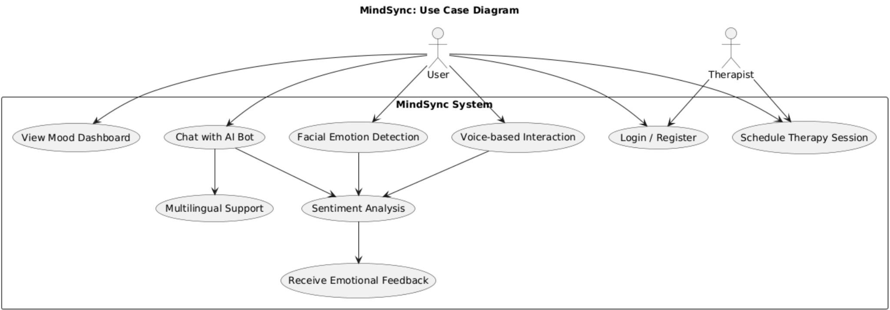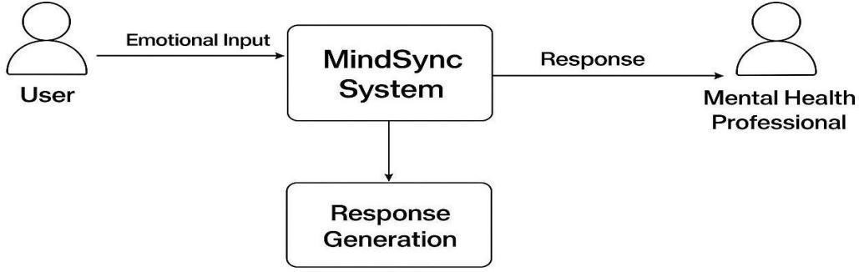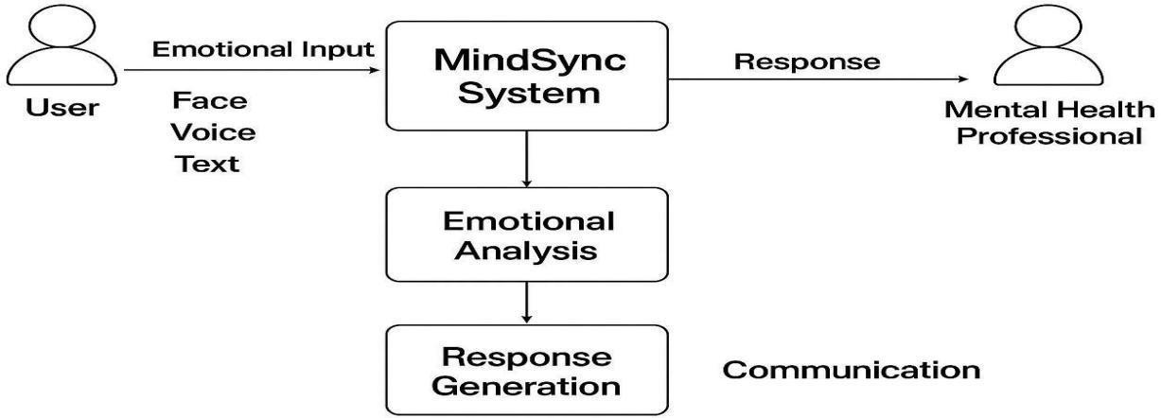

LEVEL-0 AND LEVEL-1

DATAFLOW DIAGRAM

CLASS DIAGRAM

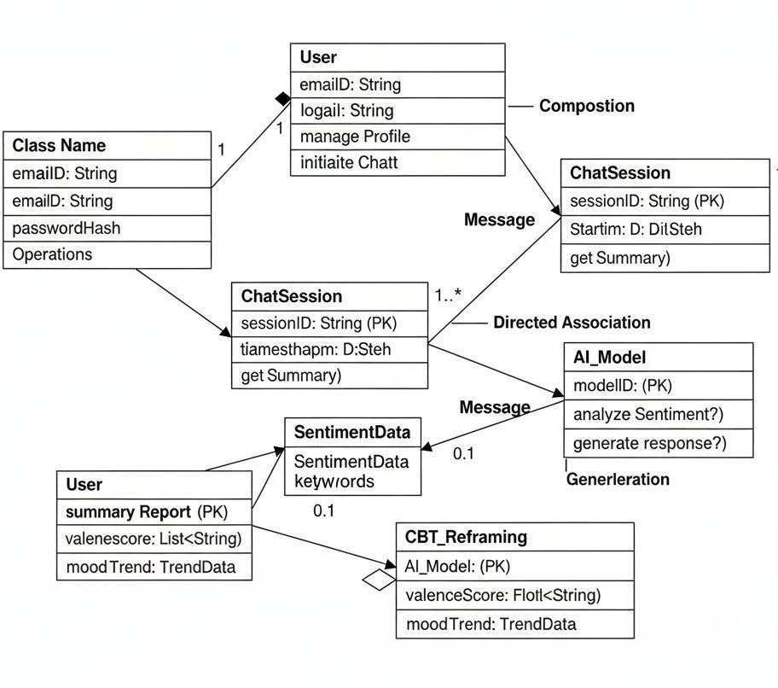

## Proposed System

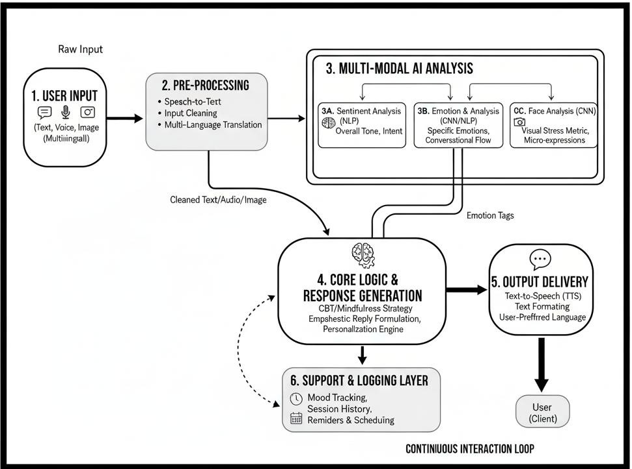

MindSync Workflow Summary

* Input: User provides Text, Voice, or Face data.
* Pre-processing: Input is cleaned, Voice is converted to Text, and Multi-language Translation ensures universal understanding.
* Analysis (Multi-Modal): Parallel AI models determine Sentiment (NLP), specific Emotion, and Visual Stress (Face Analysis).
* Core Logic: The combined analysis is used to retrieve and apply a CBT/Mindfulness Strategy.
* Output: A personalized, empathetic reply is generated, formatted (Text/Audio), and delivered to the User.
* Logging & Loop: Session details and mood metrics are recorded for history, and the system awaits the next input to restart the continuous interaction loop.

## HARDWARE AND SOFTWARE

REQUIREMENTS:

Server Requirements

CPU: Multi-core (for concurrency). RAM: 16 GB+ (for loading AI models).

GPU: NVIDIA w/ CUDA (Recommended for AI speed). OS: Linux/Windows Server.

II. Software Requirements Core: Python 3.x

Backend: Flask/SocketIO (Server/Live Chat).

AI: PyTorch, TensorFlow, Transformers (Deep Learning). I/O: SpeechRecognition (Voice) & OpenCV/FER (Face).

III. Client Requirements

Browser: Modern (supports WebSockets). Hardware: Mic + Webcam (for multimodal input). Network: Stable, High-Speed Internet.

### Module Description/ Component Specifications

1. Core Intelligence Modules

Multimodal Emotion Analysis: Checks emotion from text, voice, and face simultaneously for highest accuracy. Response Generation: Creates helpful replies using rules from CBT (Cognitive Behavioral Therapy) and Mindfulness.

Crisis Detection: Instantly flags high-risk inputs and provides emergency helpline support.

1. Input/Output (I/O) Modules

Multilingual Interaction: Supports chatting in English, Tamil, and Hindi.

Speech-to-Text (S-T-T): Converts what the user says into text for the AI to read. Text-to-Speech (T-T-S): Converts the AI's reply back into voice for the user.

1. System and Utilities

Frontend/Backend: Uses Flask (server) and SocketIO (live chat) to run the application. Concurrency: Uses eventlet and threading to manage many users at once without slowing down.

Privacy Mode: A key feature that lets the user turn off (disable) video and audio processing if they want. Continuous Feedback: Tracks the user's mood over time to give increasingly personalized advice.

1. Specific AI Components

NLP Models (Transformers/TextBlob): Understands the meaning and feeling of the words.

CNN Models (OpenCV/FER): Used for Face Analysis to detect visual signs of emotion and stress.

# Justification for POSITIVE

1.24/7 Accessibility: Acts as an always-available emotional companion , overcoming the limits of time and location found in traditional therapy.

1. Stigma-Free & Private: Provides a confidential, private, and non-judgmental digital environment , helping individuals who hesitate to seek help due to social stigma.
2. High-Quality, Informed Support: Generates empathetic, context-aware responses guided by evidence-based Cognitive Behavioral Therapy (CBT) and mindfulness principles.
3. Advanced Accuracy: Uses multimodal analysis (text, voice, and facial expressions) to accurately interpret complex emotions, unlike basic, rule-based chatbots.
4. Inclusive & Cost-Effective: Offers multilingual support (e.g., English, Tamil, Hindi) and minimizes costs by using open-source tools, making mental health support more affordable and accessible.
5. Safety Integration: Includes a Crisis Detection and Intervention feature to provide immediate emergency helpline support when critical cues are identified.

# Experimental Results

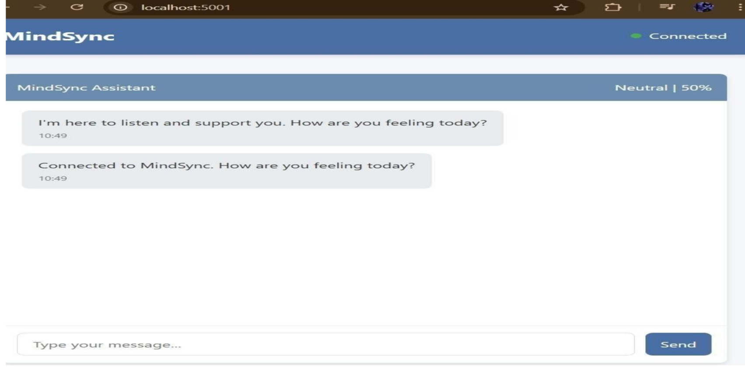

All metrics were computed for individual models (text, speech, facial) and then evaluated in multimodal fusion stage to assess combined system performance.

### Experimental Results

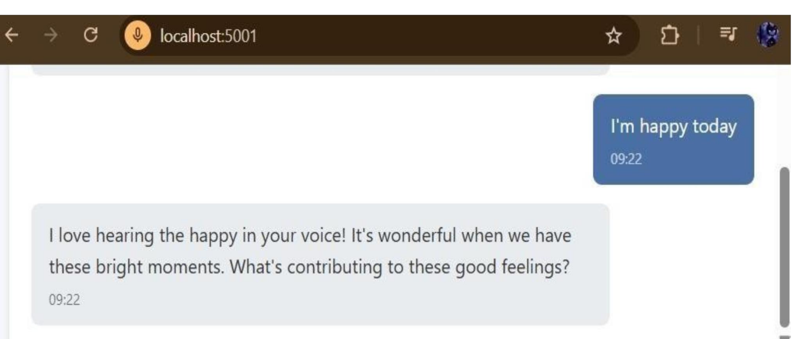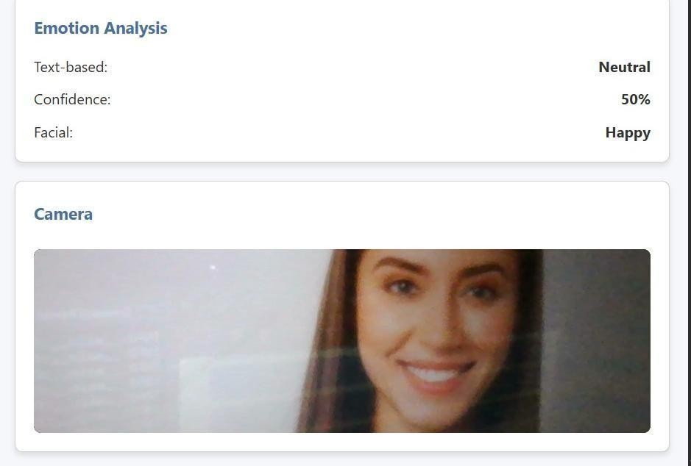

1. Text Emotion Recognition Performance
2. Facial Emotion Detection Performance

# Experimental Results

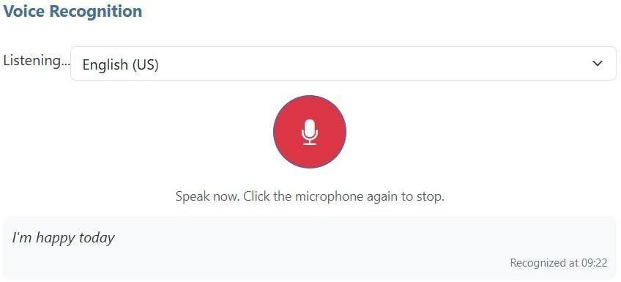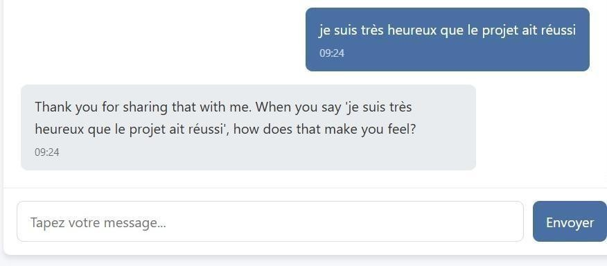

4.Voice Emotion Recognition Performance

# Experimental Results

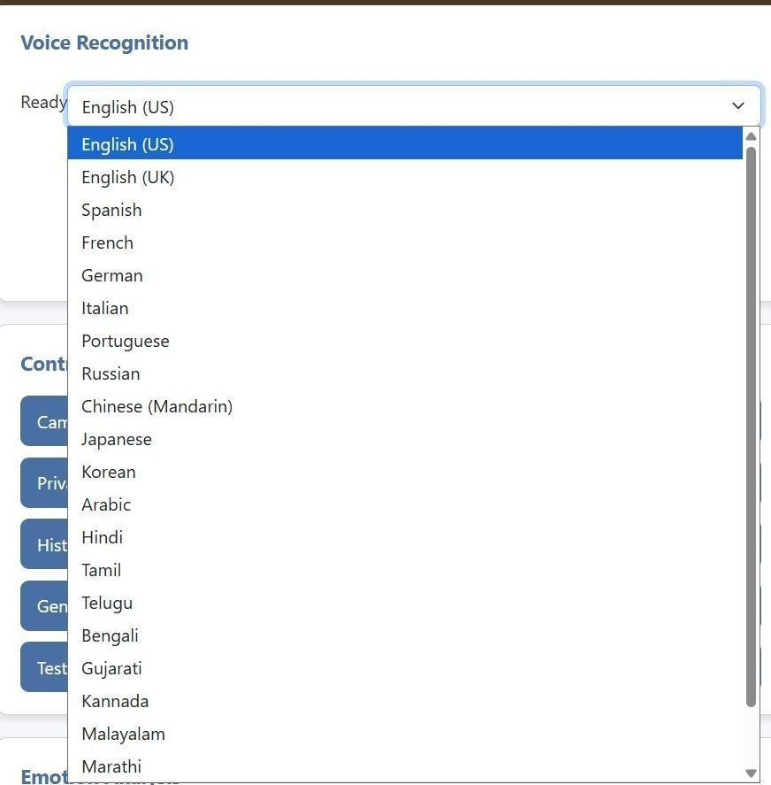

5.MULTI-LANGUAGE DETECTION

Nearly 20languages:

### Project Showcase and Future Steps

Showcase: MindSync Achievements:

The MINDSYNC system is presented as a successfully implemented, compassionate, AI-powered platform with the following core achievements: 1.Multimodal Emotional Intelligence: Successfully integrates and analyzes text, voice, and facial expressions to interpret user emotions like stress, anxiety,

sadness, and anger in real-time.

1. Therapy-Informed Dialogue: The system delivers context-aware responses and supportive dialogue based on proven psychological methods, specifically Cognitive Behavioral Therapy (CBT) and mindfulness principles.
2. Accessibility and Inclusivity: Unlike conventional, text-only systems, MindSync offers multimodal interaction and multilingual support (including English, Tamil, and Hindi).
3. Always-Available Companion: Serves as a first-level, always-available emotional companion to complement traditional therapy.
4. Ethical Design: Emphasizes privacy, empathy, and ethical handling of user data, creating a secure and non-judgmental digital environment.
5. Technical Foundation: Built using advanced AI/ML techniques including Natural Language Processing (NLP) and Facial Emotion Detection (FED), leveraging frameworks like PyTorch and TensorFlow.

Future Steps and Long-Term Goals:

1.The project outlines clear goals for future development and deployment, focusing on expanding its reach and integration: 2.Integration with Digital Healthcare: The long-term goal is to integrate MindSync into digital healthcare platforms.

1. Global Accessibility: Aims to contribute to global mental health accessibility and promote emotional resilience for all.
2. Sustained Support: Further develop the system to provide continuous engagement and personalized support through intelligent dialogue.
3. Social Relevance: Align the platform with the United Nations Sustainable Development Goal (SDG 3: Good Health and Well-being), ensuring its continued social impact.
4. Enhance Continuous Care: Focus on enhancing mental well-being through features like mood tracking, mindfulness prompts, and CBT-based interventions.

# Conclusion

=>MindSync was born from a simple, profound realization: words alone often fail to capture the full story of our feelings.

In a world where digital communication can feel isolating, this technology reaches across the void to listen not just to what we say, but how we say it. It pays attention to the subtle tremor in our voice, the fleeting shadow of worry across our face, and the hidden weight behind our typed sentences. By weaving together these different threads of expression, MindSync creates a form of digital empathy that feels genuinely human, offering a space where a person can be truly seen and understood, not just processed.

=>Beyond its ability to understand, MindSync serves as a critical lifeline, a vigilant guardian ready to offer hope in a moment of crisis. Its power is magnified by its ability to break down the barriers of language, ensuring that a cry for help is heard and answered with culturally relevant support, whether it's in English, Hindi, or any of the other languages it speaks. In regions where access to mental health professionals is a distant dream, this system becomes a bridge, providing immediate, localized guidance and transforming a moment of profound loneliness into a connection with life- saving resources.

=>Ultimately, the foundation of this entire endeavor is a deep and unwavering respect for the user. We understood that for such an intimate tool to be effective, it must be built on a bedrock of trust. This is why privacy isn't just an add-on; it's a core promise. The privacy mode creates a sanctuary where a user can share their innermost thoughts without fear, knowing they have complete control over their data. MindSync is more than just a technological achievement; it is a commitment to treating every individual with the dignity and compassion they deserve, paving the way for a future where technology serves our deepest human need for connection and care.

# Reference

1.U. Bhave, M. N. Mhatre, J. A. S. Joshi, D. J. B. Desai, and R. A. Rajeshwari, “Mind Well Solace: Your Mental Health Companion,” 2024 4th Asian Conference on Innovation in Technology (ASIANCON), Pune, India, Aug. 23–25, 2024, IEEE, pp. 1–8, 2024. doi: 10.1109/ASIANCON62057.2024.10837922.

2.B. L. Cook, A. M. Progovac, P. Chen, B. Mullin, S. Hou, and E. Baca-Garcia, “Novel Use of Natural Language Processing (NLP) to Predict Suicidal Ideation and Psychiatric Symptoms in a Text-Based Mental Health Intervention in Madrid,” Computational and Mathematical Methods in Medicine, vol. 2016, no. 1, p. 8708434, 2016. doi: 10.1155/2016/8708434.

F. A. Acheampong, H. Nunoo-Mensah, and W. Chen, “Transformer Models for Text-Based Emotion Detection: A Review of BERT- Based Approaches,” Artificial Intelligence Review, vol. 54, no. 8, pp. 5789– 5829, 2021. doi: 10.1007/s10462-021-09958-3.

R. Alderslade, A. Fawcett-Henesy, and M. Ruseva, “On the Perspectives of Public Health and What IHPA Can Contribute to Its Advancement in Practice,” Southeastern European Journal of Public Health (SEEJPH), 2018. Kaggle.com, “Suicide and Depression Detection,” 2021.

3.B. L. Cook, A. M. Progovac, P. Chen, B. Mullin, S. Hou, and E. Baca-Garcia, “Novel Use of Natural Language Processing (NLP) to Predict Suicidal Ideation and Psychiatric Symptoms in a Text-Based Mental Health Intervention in Madrid,” Computational and Mathematical Methods in Medicine, vol. 2016, no. 1,

pp. 1–8, 2016, Art. no. 8708434. doi: 10.1155/2016/8708434.

1. D. A. Akbar, D. A. D. Bewasana, A. Z. Mahfud, and T. Yulita, “InnerCheck: A New Breakthrough for Early Detection of Mental Health,” 2023 IEEE International Conference on Cryptography, Informatics, and Cybersecurity (ICoCICs), Bogor, Indonesia, 2023, pp.

281–287. doi: 10.1109/ICoCICs58778.2023.10276558.

1. B. U. Sri, V. Dasoju, G. J. Avinash, H. K. Kokutam, and M. Jilla, “SolaceNet – Anonymity Ensured Online Therapy Platform for Overcoming Barriers in Mental Health Assistance,” 2024 International Conference on Advances in Modern Age Technologies for Health and Engineering Science (AMATHES), 2024, pp. 1–8. doi: 10.1109/AMATHES61652.2024.10582070.

**Thank You**